C/C++ PAYCHECK PROGRAM LAB ASSIGNMENT AND LAB REPORT

1) Enter your name, student ID, platform (Mac or PC) and date
Name and Student ID: Jay Gupta, Student ID: 0961979
Platform (Mac, PC, Linux, etc.): PC
Development System (Visual Studio, Xcode, etc.): Visual Studio
Date: 1/28/2020

OBJECTIVES:
Enter and successfully run a C or C++ program
Use console input to read data from the keyboard
Calculate regular and overtime pay using if…else statements
Use console output to display data to the monitor

DESCRIPTION:
Design a C or C++ program that does the following: 1) Read the number of hours and the pay rate,
2) compute the gross pay including overtime at time-and-a-half, 3) change the withholding tax rate from 17% to a new value between 5% and 25%. Compute the taxes, 4) compute net pay, and 5) display the gross pay, taxes and net pay with 2 digits past the decimal point.
INPUTS | PROCESSING | OUTPUTS
Hours  PayRate | Read hours from the keyboard into a double ✔  Read payRate from the keyboard into a double ✔  Determine regularHours (up to 40) ✔  Determine overtimeHours (hours over 40) ✔  regularPay = regularHours * payRate ✔  overtimePay = overtimeHours * payRate * 1.5 ✔  grossPay = regularPay + OvertimePay ✔  taxes = grossPay * TAX_RATE ✔  netPay = grossPay – taxes ✔  Display grossPay and netPay ✔ | GrossPay

LAB REPORT:
2) Fill in the EXPECTED RESULTS and the ACTUAL RESULTS in the table below – no screenshots
Use a calculator to compute the Expected Results
Fill in the Actual Results after you have run and tested your program
TEST DATA VALUES | EXPECTED RESULTS  ?? are the computed values before the program is run | ACTUAL RESULTS  Fill in the output displayed  by the program
Hours = 39, PayRate = 20 | Your gross pay is $780.00  Your taxes are $132.60  Your net pay is $647.40 | Your gross pay is $780.00  Your taxes are $132.60  Your net pay (what you take home) is $647.40
Hours = 40, PayRate = 20 | Your gross pay is $800.00  Your taxes are $136.00  Your net pay is $664.00 | Your gross pay is $800.00  Your taxes are $136.00  Your net pay (what you take home) is $664.00
Hours = 41, PayRate = 20 | Your gross pay is $830.00  Your taxes are $141.10  Your net pay is $688.90 | Your gross pay is $830.00  Your taxes are $141.10  Your net pay (what you take home) is $688.90
DISCUSSION:
3) Complete the DISCUSSION section. It does not need to be long, but it needs to be complete.
3a) What did you do to develop the program? ("Followed the Directions" is not a complete description)

First of all, I let go of any of my previous programming experience, in order to take in this new language, and its subtle complexities. At this point in my programming career, I know it doesn’t help anyone to look directly at the source code; which is why I only consulted the code you gave me if I was very stuck and I couldn’t find the solution online. I thought of how the code works, and the background finances that the code runs on (I’m not very good with finances; I haven’t had a job yet).

3b) What problems did you have and how did you overcome the problems?

I had a few problems with getting familiar with the language; for example, I didn’t realize it was acceptable to put the constants, or any variables, for that matter, above the main() function. Apart from that, I tried to do everything on my own, such as figuring out if/else statements, the setprecision() function, etc. I used the internet (Google) to figure this out, and StackOverflow played a pretty substantial role as well.

PROGRAM OUTPUT:
4) Show five screenshots
- On-screen calculator showing the result of 40 hours * pay rate of 20
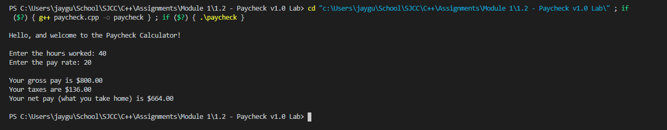
- On-screen calculator showing the result of the taxes for 40 hours and pay rate of 20
- Program output when the program is run with the hours worked less than 40
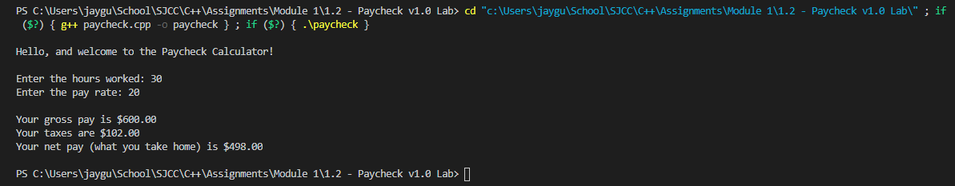
- Program output when the program is run with the hours worked equal to 40
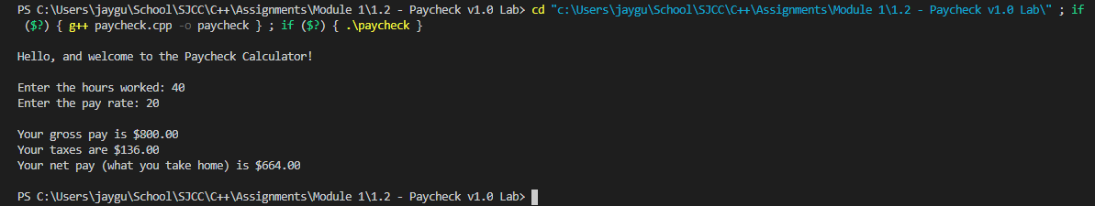
- Program output when the program is run with the hours worked greater than 40
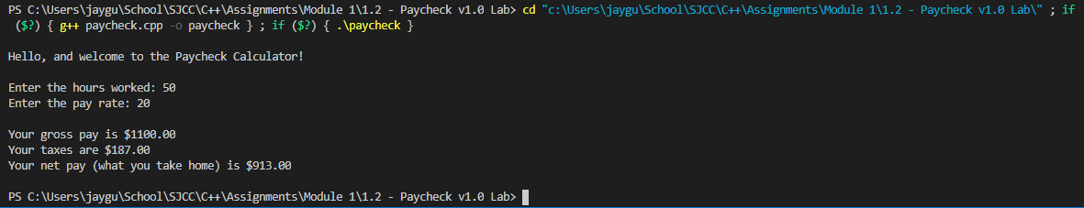
IMPORTANT: Capture only the portion of the screen that shows the calculator or program output. Do not capture the entire screen even though it may also contain the program output. Many times when I zoom in on the output window, the image resolution is so poor that I am not able to read your output. If this happens, I will ask that you resubmit your lab report.

For the Mac, hold down command + shift keys and press the 4 key to get a screenshot of a selected area of the screen. Use the mouse or touchpad to select the desired area.
Use command+V to paste the clipboard into the lab report.

For Windows, There are two ways you can capture a screen shot of only your program:
- Use Microsoft's Snipping Tool by clicking on the Start icon and selecting "All Programs" then "Accessories". Use the mouse to select the area of the screen you want to save then click Ctrl-C or select the menu items Edit-Copy to save the image to the clipboard.
- Capture the active window to the clipboard by holding down the Alt key and tapping the PrintScreen key. NOTE: some notebook computers require that you hold down a [Fn] key and Alt keys to activate the PrintScreen function. NOTE: Do not click PrintScreen without the Alt key. This would capture the entire screen which would make your program output difficult to see.
Use Ctrl+V to paste the clipboard into the lab report.

PROGRAM LISTING:
5) Copy and paste the code that YOU typed to make the program work. Your program should include a comment block at the top that shows the name of the program, date and your name.

/*
Name: Jay Gupta
Student ID: 0961979
Platform: PC
Development System: Visual Studio Code
Date: 1/28/2020

Program Name: Paycheck.cpp v1.0 Lab
Inputs: Hours, Pay Rate
Outputs: Gross Pay, Net Pay
*/

#include <iostream>
#include <iomanip>
using namespace std;

// defining the constants; variables that won't change
const double OVERTIME_RATE = 1.5;
const double TAX_RATE = 0.17; // 17%

int main()
{
// define the variables
double hours, payRate;
double regularHours, overtimeHours;
double taxes;
double regularPay, overtimePay, grossPay, netPay;

cout << "\nHello, and welcome to the Paycheck Calculator! \n" << endl;

// get hours and payRate from the user
cout << "Enter the hours worked: ";
cin >> hours;

cout << "Enter the pay rate: ";
cin >> payRate;

// if hours is less than or equal to 40, then there is no overtime
if (hours <= 40) {
regularHours = hours;
overtimeHours = 0;
} else {
regularHours = 40;
overtimeHours = hours - 40;
}

// computation
regularPay = regularHours * payRate;
overtimePay = overtimeHours * payRate * OVERTIME_RATE;
grossPay = regularPay + overtimePay;
taxes = grossPay * TAX_RATE;
netPay = grossPay - taxes;

// display the data to the user

cout << fixed;
cout << setprecision(2);
cout << "\nYour gross pay is $" << grossPay << endl;
cout << "Your taxes are $" << taxes << endl;
cout << "Your net pay (what you take home) is $" << netPay << endl << endl;

return 0;
}

